BUSINESS REQUIREMENT
DOCUMENT OF JSW ENERGY

PROJECT DETAILS
PROJECT NAME
Fundamental & Financial stock Analysis of JSW ENERGY
CREATOR
Piyush Bhushan Naik
DOCUMENT NO. | DATE | VERSION NO.
1 | 20-03-2025 | 1

1. EXECUTIVE SUMMARY
This BRD will act as a roadmap for a project, outlining the business's objectives, and scope, ensuring all stakeholders have a shared understanding and alignment, leading to efficient project execution and a successful outcome
The overview of this project stands on the objective which is to analyze different Financial statements and Stock market data of JSW Energy for the review insights.

The Scope of project aims to analyze current one-year performance of stock of JSW Energy and to give many financial calculation, analysis and performance evaluation between year 2020 to 2024 period in various financial statements i.e. Balance sheet, Income Statement and Cashflow Statement with the help of the analysis and visualization tools like Excel and Power BI.

The outcome of project focuses to give the best beneficiary requirements of cleaned and analyzed data for investors and traders for the future investment, establishment, or further decisions.
The purpose of making this business requirements document is to simplify the analysis and findings in a report document form for better understanding.
The audience for this business requirements document focuses on the investors, stakeholders, traders and financial & analytical authorities.

2. PROJECT SCOPE
Provide a high-level description of the project’s scope, including a list of project-specific goals, tasks, deliverables, costs, deadlines -- everything that is “in” and “out” of scope for the project. This information provides team members with guidelines for the scope of the project, so they can plan and resource accordingly.
The Scope of project aims to analyze and interpret current one-year performance of stock of JSW Energy and to give many financial calculation, analysis and performance evaluation between year 2020 to 2024 period in various financial statements i.e. Balance sheet, Income Statement and Cashflow Statement with the help of the analysis and visualization tools like Excel and Power BI.
The outcome of project focuses to give the best beneficiary requirements of cleaned and analyzed data for investors and traders for the future investment, establishment, or further decisions.

ANALYSIS TOOLS | IN-SCOPE ITEMS
Item 1: MS EXCEL | Item 1: Data Interpretation & Analysis
Item 2: Power BI | Item 2: Data Modelling
Item 3: MS WORD | Item 3: Data Visualization
Item 4: | Item 4: Data Validation

3. PROJECT DESCRIPTION AND ANALYSIS

3.1 STOCK DATA ANALYSIS
Stock Data Analysis of JSW ENERGY

From Past 1-year period of March 2024 to march 2025 Avg of 52W H has been 748.06 and average of 52W L has been 335.86.
The closing price total from march 2024 to march 2025 has been 157.20K and opening price total has been 157.69k.
Within that time period the total number of shares traded for the stock is 990M.

By Summing Quarterly aggregates of 52W h & 52W L Q1 has the highest 52w h value of 24k and Q2 has the lowest with 15k.
For the 52k low Q4 has highest value of 50 k and Q2 has lowest with 40k.

May month has seen the highest sum of volume of around 0.16 billion while August has the lowest with 46 million.
For the Monthly Totals of aggregating
January has highest sum value of 52w L with 10k
and also has highest sum value of 52w H with 18k
June has lowest sum value of 52w L with 4.7k
March has lowest sum value of 52w H with 11.4k.

For the Day wise Totals of aggregating
Tuesday has highest sum value of 52w L with 17.3k
and also has highest sum value of 52w H with 38.7k
Saturday has lowest sum value of 52w L with 692.20
& has lowest sum value of 52w H with 1.4k.

As we analyzed the 15th day of months has an average of very low sum of stock trading prices with lowest sum of
closing prices with 3.1k and lowest sum of opening price with 3.1k.
18th day of months has an average of very high sum of stock trading prices with highest sum of
closing prices with 6.4k and highest sum of opening price with 6.39k.

23rd day has highest average opening and closing stock price with 668.27 & 665.79 respectively
7th day has the lowest average closing stock price with 607.63 & 20th day has the lowest average opening stock price with 614.30
4th,5th,9th,20th,22th,24th,25th & 28th days has seen the most fluctuation between opening and closing stock prices i.e. of 10 or more.
other dates have been steady in terms of fluctuation between stock prices.

Trend analysis of Stock price
During period of march 2024 to march 2025, february month of 2025 has seen the lowest stock trading price of 466.90 and september 2024 has seen the highest stock trading price with 746.53
From march 2024 the stock prices have seen a steady growth with less fluctuation in prices up to sept 2024, but from oct 24 it has seen a steady decline in stock prices till march 25.
By using the Excel formulas and line chart the forecast has been made that April 2025 will see an increase in stock price but after it may see a steady downwards in price fluctuation
during next 5 months as per the trend analysis.

Volume analysis
During the time period on an average may 2024 has seen the highest volume of socks with around 7.1 M, while October 2024 has seen the lowest with only 2.1M of volume.
From May-august of 2024 it has seen a sharp decline in the volume of stocks.
From Oct24 to feb25 the recovery has been good and it has seen an exponential increase in the growth of the trading volume.
By using the Excel formulas and line chart the forecast of trend has been made that from April 2025 the trading volume may see a steady increase for further 5 months.

What it concludes
As per the trend analysis of stock price and volume, it generally signals a bearish trend, indicating a strong selling pressure and potentially a weakening of the downtrend.
This suggest that a significant number of investors are actively selling the stocks even as the price falls.
The pattern suggests that there is a considerable selling pressure indicating that many market participants are selling the asset, which could lead to further price declines.

ROI(Return on Investment) Calculation
Over the past year from mar 2024 to March 2025, JSW Energy has demonstrated a return of investment of average 6.87% per day while past 1 year overall has seen the ROI of 16.6%.
While April 2024 has seen the highest ROI of 103% and Jan 2025 has the lowest ROI of -39.2%.
Last month of February 2025 has demonstrated the ROI of -10%
For the future forecasting ROI might increase for next 3 months of April, May, June while may decline for July, August, September for further 6-month period with a rate of -0.38%

What it concludes
We can conclude it as strong ROI for the business as 16.6% considered a good one and a ROI of 7% avg per day is generally good enough and we can have a good reasonable
expectation to have from the investment.

Standard deviation and Variance calculation
During period of march 2024 to march 2025 the Average Return Per day is 0.03%
The Standard Deviation for daily return is found out to be 2.95%
The variance of 0.09% has been detected between days during this time period

What it Concludes
A typical day trading profit per day is between 0.03 and 0.13 percent. This corresponds to a monthly profit of between 1 and 10 percent for successful day traders.

Moving Averages Calculation
From march 2024 to march 2025 the time period count was 247 days.
The SMA (simple Moving Average) in between that time period was 636.45.
By taking 10 days of EMA (Exponential Moving average) the value came out to be 595.59

What it concludes
As the EMA is less than the SMA in the calculation, it suggests a potential bearish trend or a period of consolidation, as the EMA being more responsive to recent price
changes, lags behind SMA, indicating a potential downtrend or sideways movement.

RSI (Relative Strength Index) calculation
During period of march 2024 to march 2025, by taking the input period of default i.e 14 days,
the RSI calculated at 48.9 during the year with the RS of 1.22.

What it concludes
As per the calculation the RS>1 is indicating that the JSW energy asset has outperformed the benchmark. While an RSI of 48.9 indicating that the asset is neither
significantly overbought nor oversold, and suggests a neutral or slightly bearish momentum, as it is below the 50-neutral line.

MACD (Moving average Convergence Divergence) calculation
As per the requirements of MACD calculation requires two types of EMAs of security's price,
We have made 12-day EMA and 26-day EMA for the analysis.
The 12-day EMA is found out to be 601.14 and 26-day EMA at 583.94.
The MACD line average found out to be 21.86.
The signal line found out to be -5.13.
MACD histogram value was calculated & it was 29.18.

What it Indicates
The MACD Analysis of JSW ENERGY indicates that the 12-day EMA is greater than the 26-day EMA, suggesting a potential bullish trend or buy a signal
because short term EMA is moving faster and higher than long term EMA.
The trend signals often interpreted as "golden cross".
As the average of MACD line is positive, which signals an upward momentum as the bullish momentum is picking pace. Also, a positive MACD histogram
suggesting that MACD line is above 9-day EMA, further reinforcing the bullish trend.
The negative value of signal line indicating a downward momentum in the asset's price, suggesting a potential sell signal.

3. PROJECT DESCRIPTION AND ANALYSIS

3.2 FUNDAMENTAL ANALYSIS OF FINANCIAL STATEMENTS
Horizontal Analysis of Income Statement (from 2020 to 2024)

By taking 2020 as a base year we analyzed that
Total revenue has seen a decrease in % in 2021 & 2022 at rate of -34% and -14% respectively,
but from 2023 and 2024 it has seen an exponential growth of 33% and 18% respectively
overall the Income has grown at rate of 1%
also
Total expense has seen a decrease in % in 2021 & 2022 at rate of -35% and -26% respectively,
but from 2023 and 2024 it has seen an exponential growth of 24% and 1% respectively
overall the expense has fell at rate of -9%

During 2021 JSW ENERGY incurred a significant loss of -63% for the operations while -23% loss incurred if we calculate loss Before Exceptional, Extraordinary Items and Tax
But after that the following 3 period it has grown at a significantly profit rate of 14%,43%,91% respectively foe 2022,2023 & 2024.

overall it has grown at a profit rate of 21%.
Earning per share has been 21% during 5 years
And the equity dividend rate has been same for each year at rate of 20% with dividend of ₹2 per share

Horizontal Analysis of Balance sheet (from 2020 to 2024)

By taking 2020 as a base year we analyzed that
Total equity share has seen a significant growth on average rate of 43.19% increase during these 5 years
With an overall total 28,261 cr. of liabilities it has grown at a significant growth rate of 45% on average.

2021,2022 were on the negative side with -26% & -23% respectively while 2023,2024 has grown at rate of 101% & 129% respectively
With an overall total 91,503.53 cr. of assets it has grown at a significant growth rate of 44% on average.
2021,2022,2023 & 2024 has grown at rate of 9%, 23%, 62% & 82% respectively
Total Working capital stands at negative 696 cr.
Current investment has been also in negative impact at decline rate of -32%.

Variance analysis of Income statement

By doing the variance analysis and comparing the values in between 2023 and 2024, here are some key insights
From 2023 to 2024 Total revenue has fell from 6019.08 crore to 5339.49 crore at rate of 11.29%.
From 2023 to 2024 Total expense has fell from 5109.47 crore to 4158.1= crore at rate of 18.62%.
During the 1-year time period the amount in profit has increased with an amount of 239 crore at a rate of 33.64% prior to the previous over.
The earning per share has increased from previous year at rate of 33.60%.
The total variance has come out to be negative 125.99 crore prior to the previous year.

Vertical Analysis of Income Statement

Revenue from operations has the highest hold among all the revenues during the time period
The total V% points was 1.23% between 2023 & 2024 in terms of revenue
While Cost of Fuel has the highest hold among all the expenses.
Overall 69% of the expense has been spent on fuel cost in 5 years
While prior to previous year i.e. 2023 in 2024 it has fell by -5.64%
From the expenses finance cost has been increased from 5% to 11% in 2023 to 2024 respectively.
JSW Energy's profit has grown by 30.46% over 5 years and from 2023 to 2024 it has shown profit rate of 11.38%.
Total tax expense rate has been 21% in between 5 years period on average,
while the total tax expense has reduced by 11.3% in 2024 as compared to 2023.

Vertical Analysis of Balance sheet

Total share capital has been 13% among the total shareholders’ funds in between 5 years period.
while it has decreased by 1% in 2024 as compared to 2023.
Short term Borrowings marks 5.93% of the liabilities while long term borrowings marks 66.4% of the total liabilities,
By that total debt has been 72.4% of the total capital and liabilities during 5 years.

In between 2023 to 2024 the short-term borrowings rate has reduced by -3.8% and long-term borrowings has increased by 3.8%
From total assets fixed assets and total non-current investments marks most part with a rate of 28.36% and 62.38% respectively
while during 2023 to 2024 fixed assets dropped by 3% and non-current investment increased by 3%.
Inventories owes 3.1% of the total assets, while it has decreased by -1.78% in 2024 prior to 2023.

Ratio Analysis calculation (of year 2023 and 2024)

As per the analysis and calculations
In 2023 and 2024 current ratio has improved from 0.53 to 0.57 which is considered not good, it is indicating that the company may have difficulties meeting its short-term obligations.
In 2023 and 2024 debt to equity ratio has improved from 0.61 to 0.63 which is considered good, it is indicating that the company has a healthy balance between debt and equity financing, the company is not overly reliant on debt.
The profit margin ratio has increased from 11.8% to 17.8% as we can consider as healthy as for a power industry 10-20 % is considered good for utility.
The return on equity has increased from 6.7% to 7.8% which generally is average for a Power industry, may not be ideal breaker.
The return on assets has increased from 4.7% to 5.1% which can be considered good but not exceptional, as it falls within the typical range for asset heavy industries.
The Asset turnover ratio has decreased from 0.085 to 0.053 signifies that the company isn't effectively using its assets to generate sales or revenue.
*It might be low efficiency as company's assets are not generating enough revenue to cover their value.
*This could have been with potential issue with asset management, under utilization of assets or poor sales performance.

Actionable insights

Based on the findings the company can take steps to improve asset utilization
*optimize inventory levels
*improving sales strategies
*Evaluating and potentially divesting underperforming assets.
Meanwhile inventory turnover has increased from 12.8 to 16.4 indicating an effective demand forecasting.
As the working capital turnover found out to be -0.69 in 2024 indicating that it is not generating enough sales from its available working capital.
Dividend yield has increased from 0.83% to 0.38%
The P/E (Price to earning) ratio has increased from 62.7 to 70.9 indicating investors are willing to pay ₹70 for every ₹1 of the company's earning
potentially indicating high growth expectations or that the stock may be overvalued.
The P/B (Price to book) ratio has decreased from 7.19 to 6.49 indicating that the company's stock price is trading at 6.5 times its book value suggesting
high investor expectations for future growth.
The combination of these two high ratios suggests that the stock is potentially overvalued, with investors paying a high price for both the assets and earnings.

4. BUSINESS DRIVERS
The reasons for which JSW energy business is initiating the project analysis and Interpretation. In short, why are we undertaking the project?
Improvement in Sales | Improving sales for JSW may lead to strengthen its position by boosting investors confidence, increasing cashflow, and potentially leading to higher profits and stock prices also can further fuel the bullish trend.
Increase stock price | By increasing stock prices can benefit both company and investors with company can gain easier access to capital and can lead to increase in market capitalization also investors may see their investments grow and potentially receive higher returns.
Growth in investment | During a bull market, bond yields generally decline, making low-risk securities and financial instruments less attractive. As a result, investors may seek higher returns in the equity market, driving up demand for stocks and further accelerating market growth.
Diversification of assets | A diversified portfolio can mitigate the market volatility, which should lead to more stable returns over time. The assets in the portfolio can be reallocated as necessary for market changes or as the tolerance for risk changes while still helps to reach the financial goals.

5. PRESENT PROCESS
UNKNOWN
NO
YES
UNKNOWN
NO
YES
UNKNOWN
NO
YES
UNKNOWN
NO
NO
NO
NO
NO
NO
NO
NO
NO
NO
NO
NO
NO
NO
NO
NO
NO
NO
NO
NO
NO
NO
NO
NO
NO
NO
NO
NO
NO
NO
NO
NO
NO
NO
NO
NO
NO
NO
NO
NO
NO
NO
NO
NO
NO
NO
NO
NO
NO
NO
NO
NO

5.1 Trend Analysis
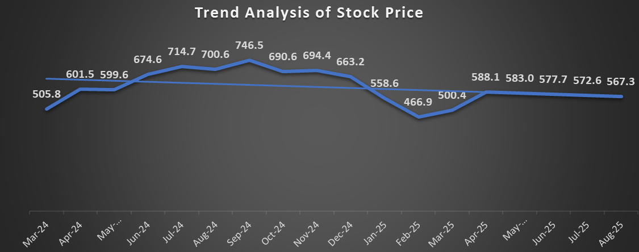
By taking the average stock price per month of 1-year period from Mar-2024 to March-2025 and by doing the trend analysis, the forecast has been made that the stock prices may continue to follow down trend for the period of next 5 months.
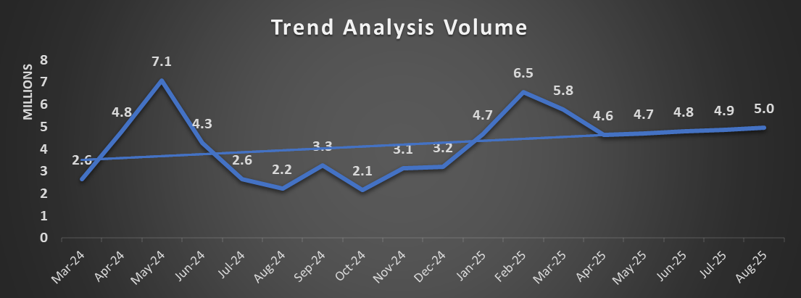

By taking the total volume per month of 1-year period from Mar-2024 to March-2025 and by doing the trend analysis, the forecast has been made that the stock volume or the volume quantity might seem to follow an upward trend for the period of next 5 months

5. PRESENT PROCESS
UNKNOWN
NO
YES
UNKNOWN
NO
YES
UNKNOWN
NO
YES
UNKNOWN
NO
NO
NO
NO
NO
NO
NO
NO
NO
NO
NO
NO
NO
NO
NO
NO
NO
NO
NO
NO
NO
NO
NO
NO
NO
NO
NO
NO
NO
NO
NO
NO
NO
NO
NO
NO
NO
NO
NO
NO
NO
NO
NO
NO
NO
NO
NO
NO
NO
NO
NO
NO

5.2 Return on Investment Per day (Month wise) & Excel Analysis
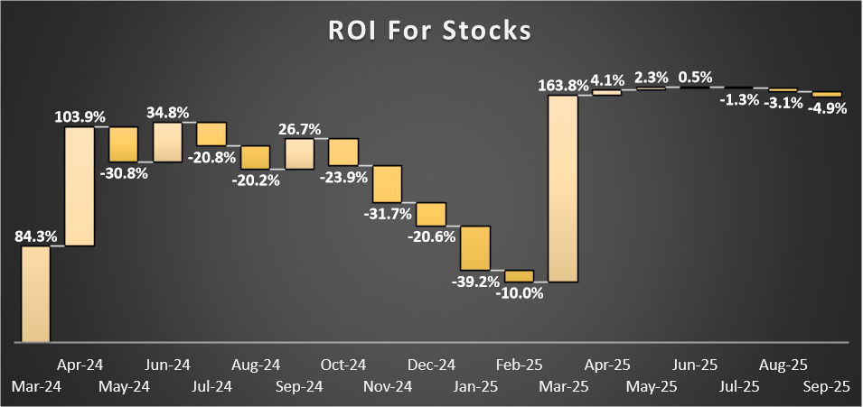

From march 2024 to March 2025 it was analyzed that there has been fluctuation in Return on investment per day for each stock month wise during that time period. while in 2024 March and April has seen the highest growth rate. By doing the trend analysis in Excel and visualizing through a waterfall chart it has been forecasted that there can be slight increase in period of upcoming April, May and June while it may also see decrease in rate in after coming July, August and September.

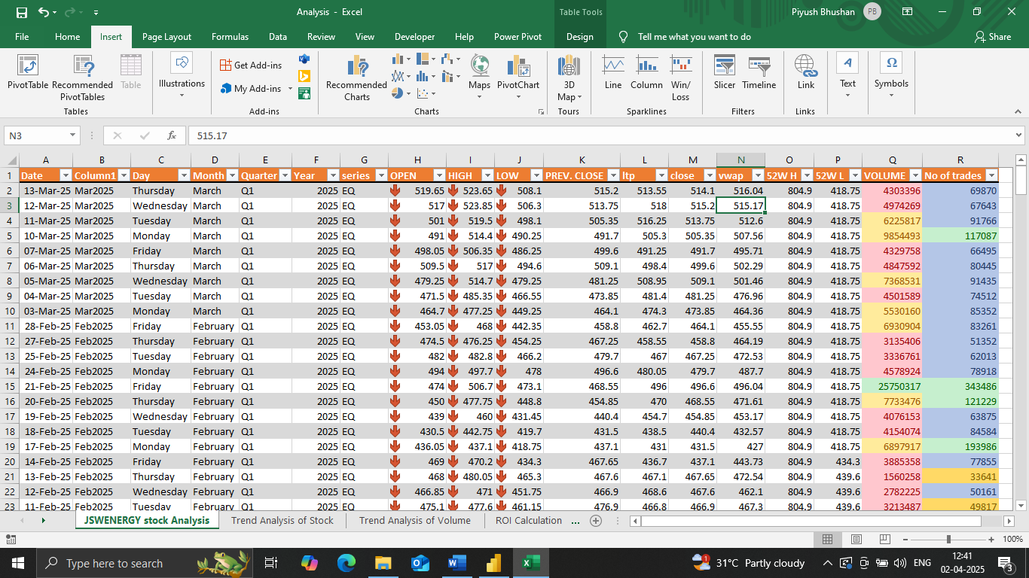
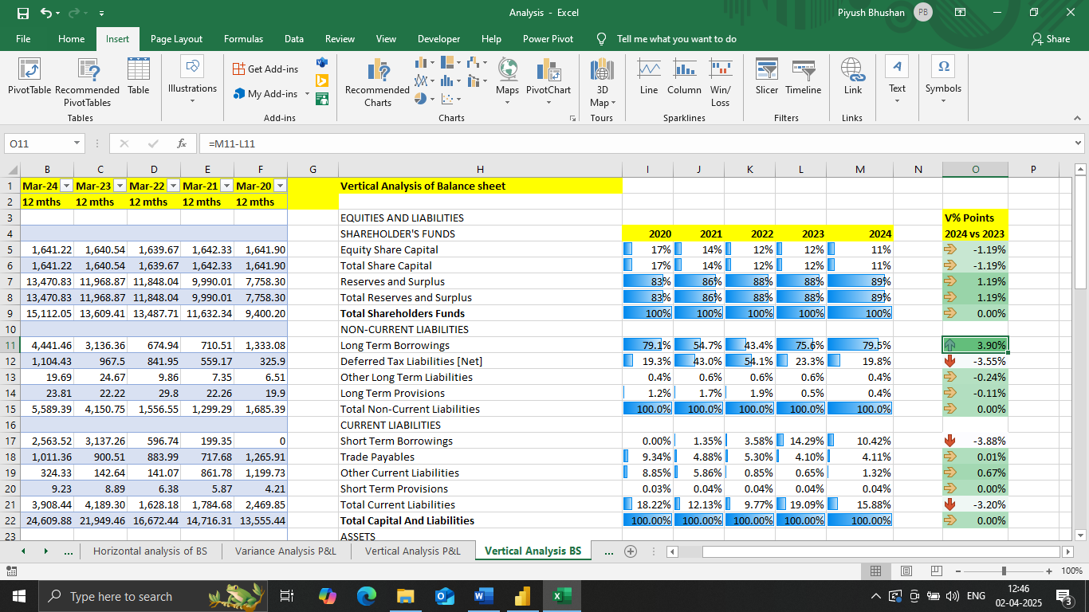

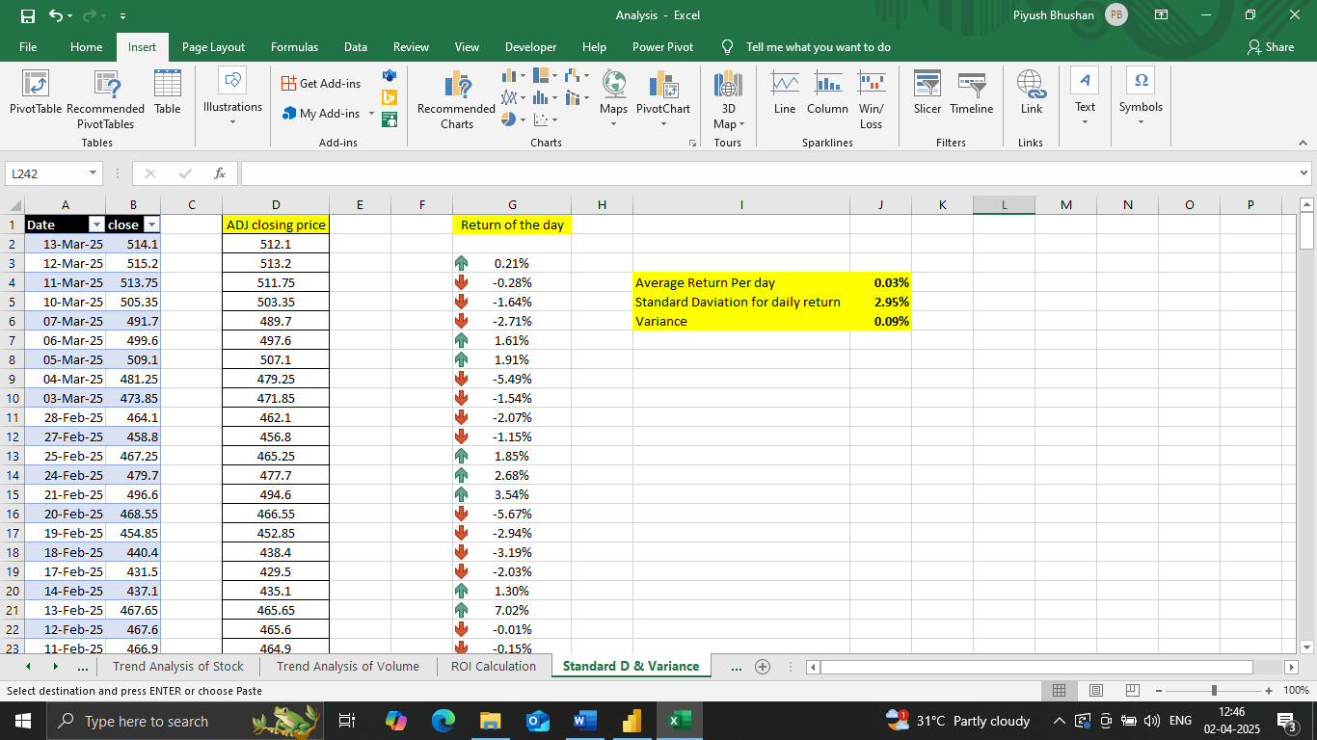

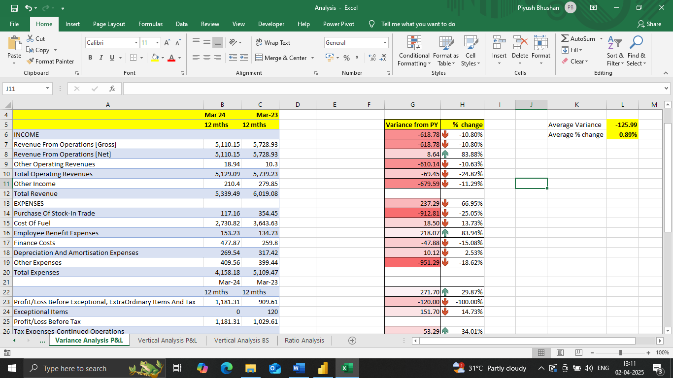
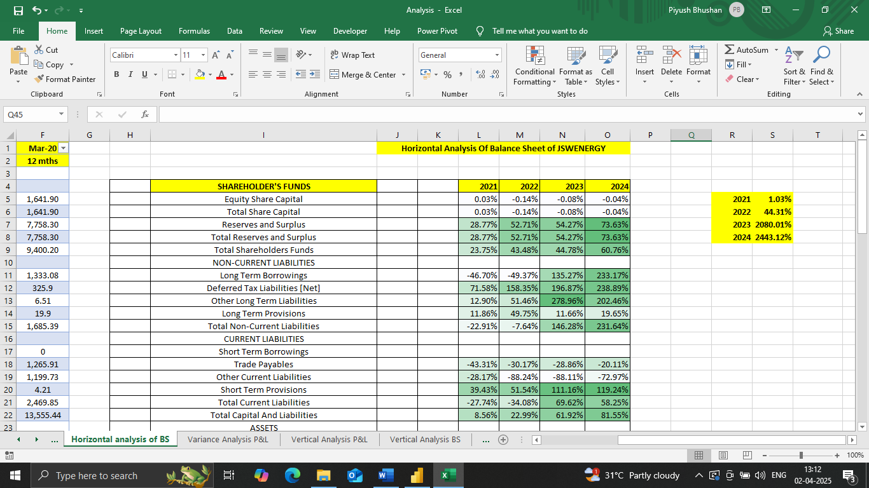

By using some Excel calculations and formulas along with excel features like Conditional formatting, Sorting, Filtering, Data validation, Data bars has been used to determine and analyze the financial and fundamental performance of stocks and assets of JSW Energy.
Power pivot has been used to clean and settle the data by removing some text duplicates and special characters.

Conditional formatting is being applied on the volume analysis, number of traders, ROI calculation, RSI value, MACD histogram values, assets of balance sheet, Horizontal analysis of income statement and balance sheet.
Data validation has been applied on the JSW Stock analysis data.
Data Bars has been inserted to the vertical analysis and variance analysis as well as to compare different financial ratios

5. DATA VISUALIZATION PROCESS
UNKNOWN
NO
YES
UNKNOWN
NO
YES
UNKNOWN
NO
YES
UNKNOWN
NO
NO
NO
NO
NO
NO
NO
NO
NO
NO
NO
NO
NO
NO
NO
NO
NO
NO
NO
NO
NO
NO
NO
NO
NO
NO
NO
NO
NO
NO
NO
NO
NO
NO
NO
NO
NO
NO
NO
NO
NO
NO
NO
NO
NO
NO
NO
NO
NO
NO
NO
NO

5.1 Visualization Analysis using Power BI
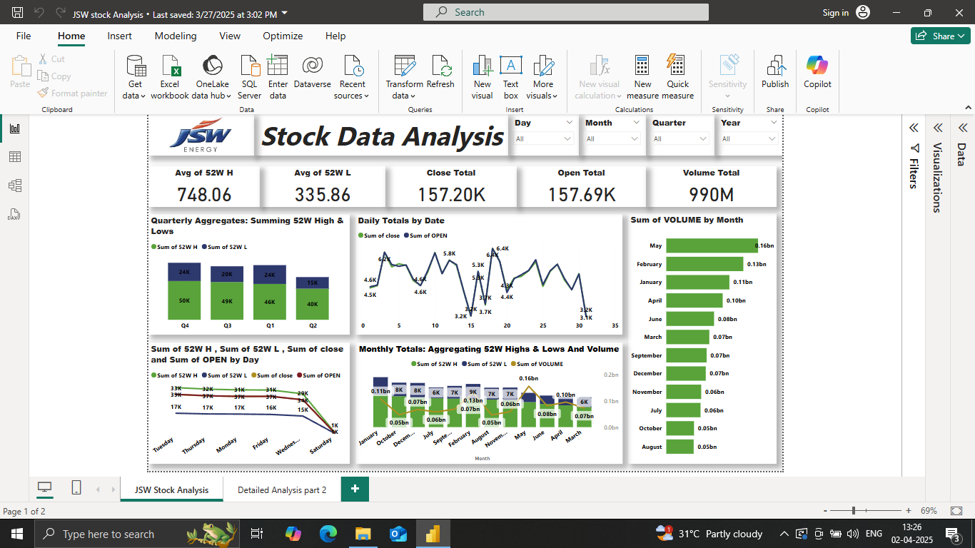

After cleaning and interpreting the analyzed data in excel, the next step was to give visual insights for the analysis of the findings and conclusions
As we know Power BI is a powerful tool for visualization analysis which is being used for better understandings and interpretation.
Some power BI features were used for analyzing the stock data like KPI’s and Cards were used for the criteria like Avg of 52W high, Avg of 52W low, Close total, Open total and Volume total.
Some visual insights that were made are
Stacked column bar chart for Quarterly Aggregates
Line chart for the Daily totals by date
Clustered column bar chart for the total volume by months
Line chart for the Sum of 52W H, Sum of 52W L, Sum of close and Sum of OPEN by Day
Line and stacked column chart for Monthly Totals: Aggregating 52W Highs & Lows and Volume
A title box and some filter slicers for day, quarter, month, year were used.

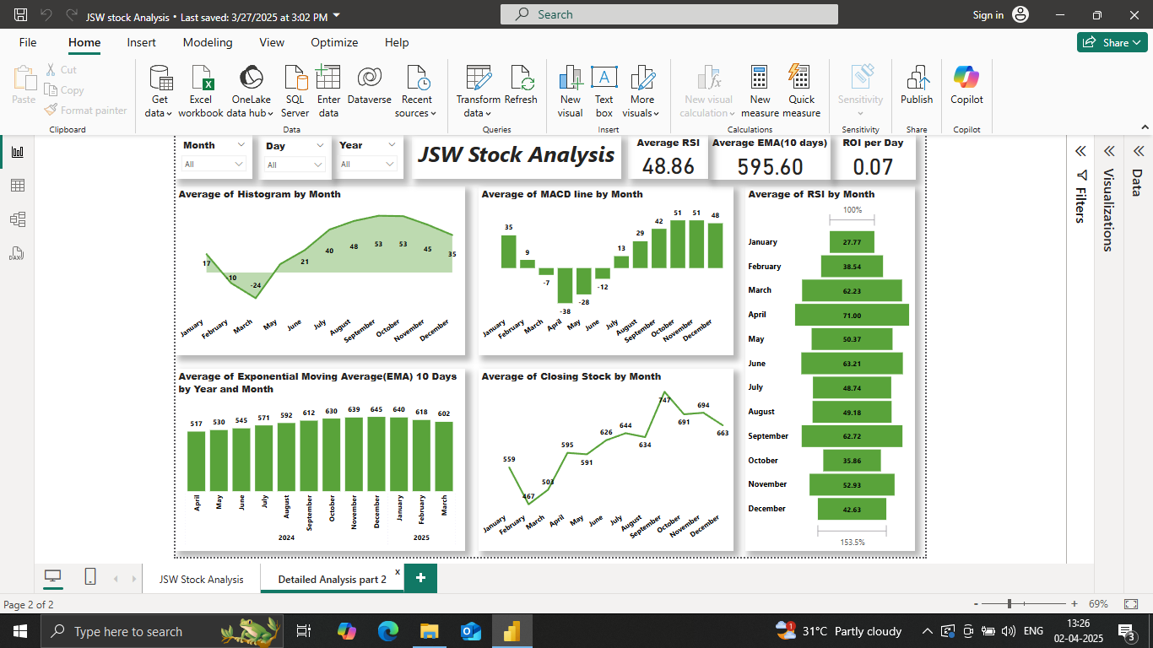

For the financial analyzed values
After cleaning and interpreting the analyzed data in excel, the next step was to give visual insights for the analysis of the findings and conclusions
As we know Power BI is a powerful tool for visualization analysis which is being used for better understandings and interpretation.
Some power BI features were used for analyzing the stock data like KPI’s and Cards were used for the criteria like Avg RSI, Avg EMA (10 days), ROI per day
Stacked area chart has been used for visualizing Avg histogram value by month
Stacked column chart has been used for visualizing Average of MACD line by Month
Funnel chart has been used for visualizing Average of RSI by Month
Line chart has been used for visualizing Average of Closing Stock by Month
Clustered column bar chart has been used for visualizing Average of Exponential Moving Average (EMA) 10 Days by Year and Month

6. FUNCTIONAL REQUIREMENTS
UNKNOWN
NO
YES
UNKNOWN
NO
YES
UNKNOWN
NO
YES
UNKNOWN
NO
NO
NO
NO
NO
NO
NO
NO
NO
NO
NO
NO
NO
NO
NO
NO
NO
NO
NO
NO
NO
NO
NO
NO
NO
NO
NO
NO
NO
NO
NO
NO
NO
NO
NO
NO
NO
NO
NO
NO
NO
NO
NO
NO
NO
NO
NO
NO
NO
NO
NO
NO
Detail the project’s functional requirements by enumerating the ways in which the current process addresses the issue and by describing the functional requirements necessary to make the project successful.
As per our analysis of JSW Energy’s functional requirements for the financial condition it is indicating that its market is on bullish and downward trend also suggesting that the stock is potentially overvalued, with investors paying a high price for both the assets and earnings

In this bullish trend market, functional requirements should include consistently rising prices, higher highs and higher lows, strong demand over supply, and positive market sentiment, often accompanied by strong economic conditions.

Rising Prices and Higher Highs/Lows:
A fundamental characteristic of a bullish trend is a sustained increase in asset prices over time, with each new high and low being higher than the previous ones.

Strong Demand:
In a bullish market, there's typically more demand for assets than supply, leading to upward price pressure.

Positive Market Sentiment:
Bullish trends are often associated with optimism and confidence among investors, leading to increased buying activity.

Strong Economic Conditions:
Bull markets often coincide with periods of economic growth, low unemployment, and rising corporate profit

7.PRIORITY
Use the following priority table. It allows you to apply a ratings system to your requirements, so you have the visibility (into the value, status, and description of each requirement) that is necessary for determining whether a particular requirement is essential to project success.
VALUE | STATUS | DESCRIPTION
Improvement in Sales | Immediate | Improving sales for JSW may lead to strengthen its position by boosting investors’ confidence, increasing cashflow, and potentially leading to higher profits and stock prices also can further fuel the bullish trend.
Growth in investment | High | During a bull market, bond yields generally decline, making low-risk securities and financial instruments less attractive. As a result, investors may seek higher returns in the equity market, driving up demand for stocks and further accelerating market growth.
Diversification of assets | Moderate | A diversified portfolio can mitigate the market volatility, which should lead to more stable returns over time. The assets in the portfolio can be reallocated as necessary for market changes or as the tolerance for risk changes while still helps to reach the financial goals.
Increase stock price | Low | By increasing stock prices can benefit both company and investors with company can gain easier access to capital and can lead to increase in market capitalization also investors may see their investments grow and potentially receive higher returns

8. NON-FUNCTIONAL REQUIREMENTS
UNKNOWN
NO
YES
UNKNOWN
NO
YES
UNKNOWN
NO
YES
UNKNOWN
NO
NO
NO
NO
NO
NO
NO
NO
NO
NO
NO
NO
NO
NO
NO
NO
NO
NO
NO
NO
NO
NO
NO
NO
NO
NO
NO
NO
NO
NO
NO
NO
NO
NO
NO
NO
NO
NO
NO
NO
NO
NO
NO
NO
NO
NO
NO
NO
NO
NO
NO
NO
In the context of JSW Energy which indicates bullish trend market (a market where prices are generally rising), non-functional requirements focus on the quality of the system or process, rather than what it does, and include aspects like performance, scalability, security, and maintainability
INDICATORS | REQUIREMENT
Performance | Response Time: How quickly the system or process reacts to user inputs or market changes, especially during periods of high activity.  Throughput: The ability to handle a large volume of transactions or data updates efficiently.  Transaction Speed: The speed at which individual transactions or actions are processed.
Scalability | Horizontal Scalability:  The ability to handle increased workloads by adding more resources (e.g., servers, processors)  Vertical Scalability:  The ability to handle increased workloads by upgrading existing resources (e.g., more powerful servers).  Capacity Planning:  Ensuring that the system or process can accommodate anticipated future growth in users, data, or transactions.
Security | Data Protection:  Implementing measures to prevent unauthorized access, modification, or loss of sensitive information.  Access Control:  Ensuring that only authorized users or processes can access specific data or functionalities.  Authentication and Authorization:  Verifying the identity of users and granting them appropriate access levels
Maintainability | Modularity:  Designing the system or process in a way that allows for easy modification and updates.  Testability:  Making it easy to test and verify the functionality and performance of the system or process.  Documentation:  Providing clear and comprehensive documentation to aid in maintenance and troubleshooting.
Reliability and Availability | Fault Tolerance: Ensuring that the system or process can continue to operate even if some components fail.  Recovery: Implementing mechanisms to quickly restore the system or process to a functional state after a failure.  Uptime: Maintaining a high level of availability and minimizing downtime.

9. REFERENCES
UNKNOWN
NO
YES
UNKNOWN
NO
YES
UNKNOWN
NO
YES
UNKNOWN
NO
NO
NO
NO
NO
NO
NO
NO
NO
NO
NO
NO
NO
NO
NO
NO
NO
NO
NO
NO
NO
NO
NO
NO
NO
NO
NO
NO
NO
NO
NO
NO
NO
NO
NO
NO
NO
NO
NO
NO
NO
NO
NO
NO
NO
NO
NO
NO
NO
NO
NO
NO
Provide links to all referenced resources (websites, documents, etc.) throughout this document.
NAME | LOCATION
NSE JSWENERGY Historical data | https://www.nseindia.com/get-quotes/equity?symbol=JSWENERGY
Money control JSW ENERGY Balance sheet | https://www.moneycontrol.com/financials/jswenergy/balance-sheetVI/je01
Money control JSW ENERGY P&L Statement | https://www.moneycontrol.com/stocks/company_info/print_main.php
Yahoo Finance JSW ENERGY Balance sheet | https://finance.yahoo.com/quote/JSWENERGY.NS/balance-sheet/
Yahoo Finance JSW ENERGY Income Statement | https://finance.yahoo.com/quote/JSWENERGY.NS/financials/
Yahoo Finance JSW ENERGY Cashflow Statement | https://finance.yahoo.com/quote/JSWENERGY.NS/cash-flow/

DISCLAIMER

Any articles, templates, or information provided here on the website are for reference only. While we strive to keep the information up to date and correct, we make no representations or warranties of any kind, express or implied, about the completeness, accuracy, reliability, suitability, or availability with respect to the website or the information, articles, templates, or related graphics contained on the website. Any reliance you place on such information is therefore strictly at your own risk.

